**Travel Mates Planner**

**Design Document**

**Version 1.0.0**



**Group Id:** F2302A92C6 **(BC170404562)**

**Supervisor Name :** Komal Saleem

**Revision History**

|  |  |  |  |
| --- | --- | --- | --- |
| **Date (dd/mm/yyyy)** | **Version** | **Description** | **Author** |
| 17/01/2024 | 1.0.0 | Introducing the **"Travel Mates Planner"** – a user-friendly web application designed to streamline trip planning for travelers. With a strong emphasis on ease of use and an array of comprehensive features, this app offers an all-in-one solution for organizing travel itineraries, booking accommodations, and exploring tourist attractions seamlessly.  Furthermore, the application is poised to enhance the revenue streams of travel agencies by automating their booking processes. The incorporation of online payment functionality ensures efficient business generation for travel agencies. The **"Travel Mates Planner"** aims to not only simplify the travel planning experience for individuals but also contribute to the growth and effectiveness of travel agency operations. | BC170404562  EJAZ UL HAQ |
|  |  |  |  |
|  |  |  |  |
|  |  |  |  |

**Table of Contents**

1. Introduction of Design Document
2. Entity Relationship Diagram (ERD)
3. Sequence Diagrams
4. Architecture Design Diagram
5. Class Diagram
6. Database Design
7. Interface Design
8. Test Cases

1. Introduction of Design Document

The **"Travel Mates Planner"** Design Document serves as a comprehensive guide outlining the architectural and functional aspects of the proposed system. This document provides a detailed insight into various design components, including Entity Relationship Diagram (ERD), Sequence Diagrams, Architecture Design, Class Diagram, Database Design, Interface Design, and Test Cases.

The purpose of this phase in the software development project is to establish a clear understanding of the system's structure, functionality, and interactions among its components. Designing these elements in advance helps streamline the development process, ensuring that the team is aligned on the project's goals and functionalities.

This document aims to:

1. Define the relationships among entities using the Entity Relationship Diagram (ERD).
2. Illustrate the sequence of tasks for each use case through Sequence Diagrams.
3. Present the overall system architecture with a Tiered Architecture Design Diagram.
4. Detail the structure of system classes using the Class Diagram.
5. Outline the database structure with the Database Design Diagram.
6. Provide a visual representation of the system's interfaces through Interface Design screenshots.
7. Specify the test cases for each use case scenario to ensure thorough testing during development.

The successful completion of this design phase lays the foundation for the subsequent development and testing stages of the **"Travel Mates Planner"** project.

1. Entity Relationship Diagram (ERD) (To be developed using Microsoft Visio or any other drawing software of your choice)

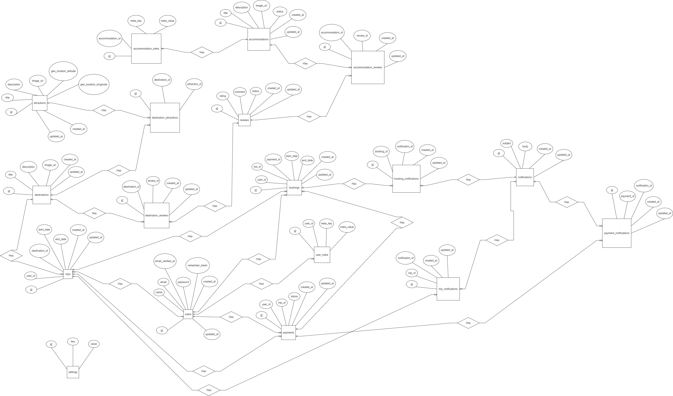

1. Sequence Diagrams (To be developed using Rational Rose or any other drawing software of your choice)

**For Admin:**

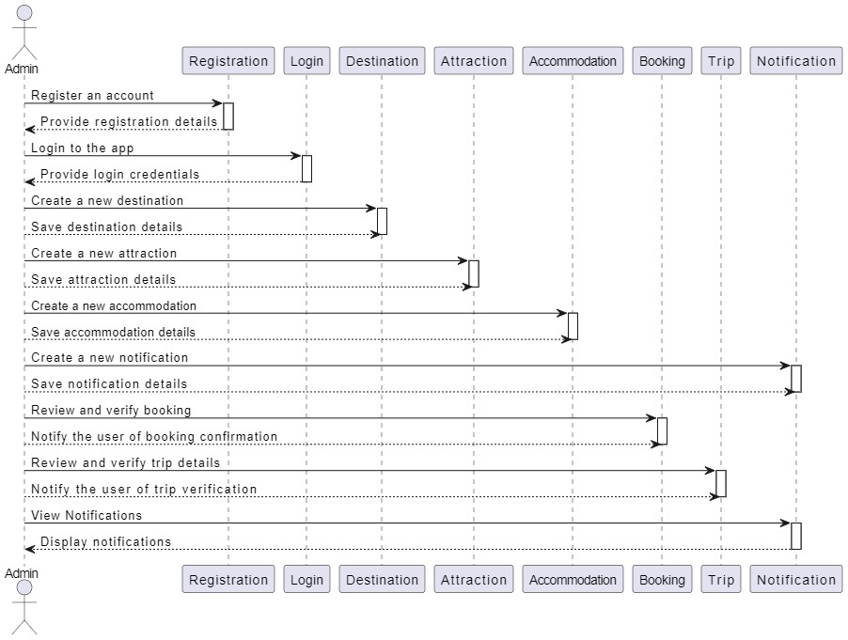

**For User:**

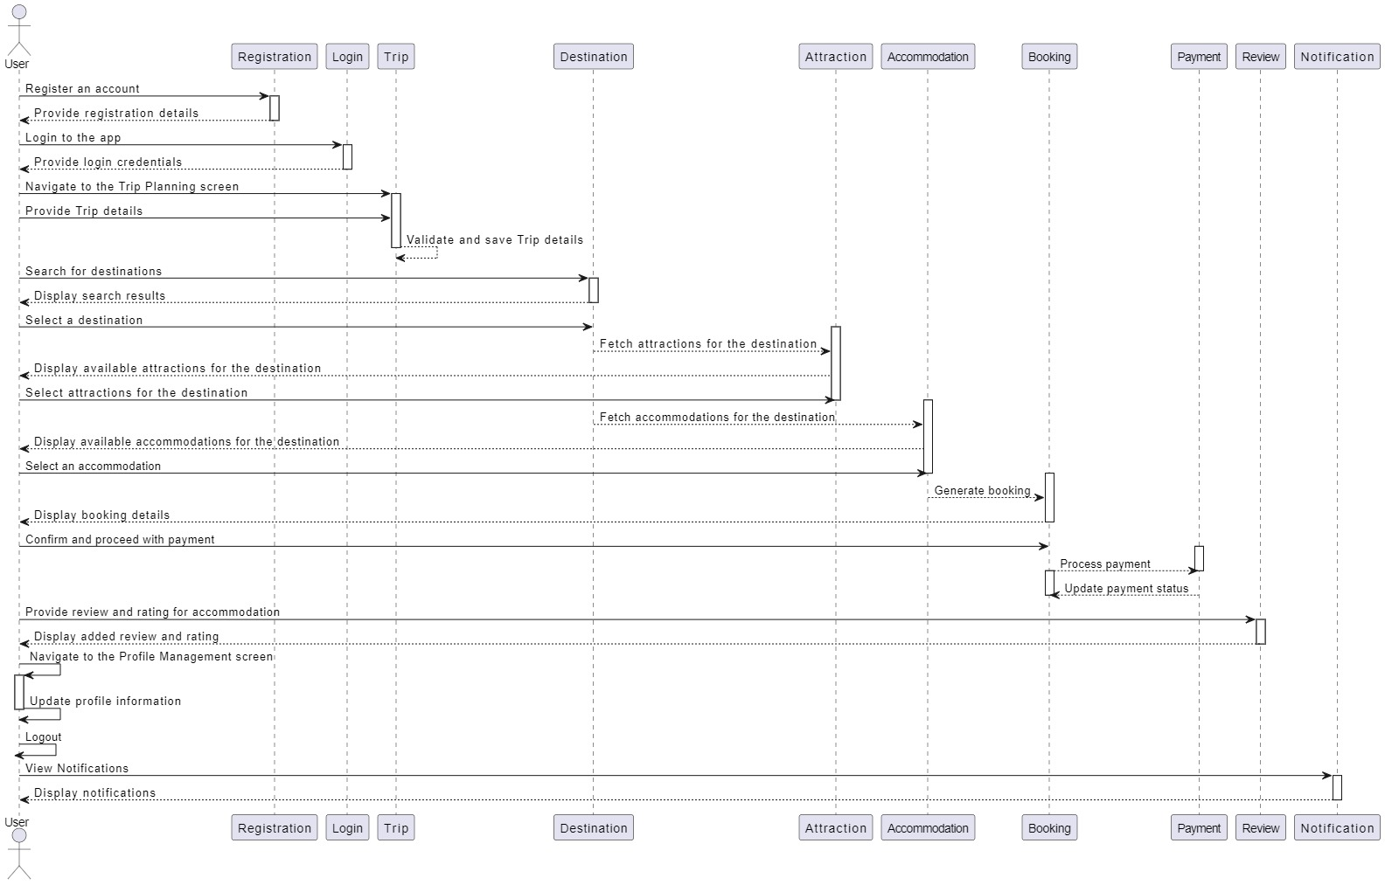

1. Architecture Design Diagram

**Fig 01:**

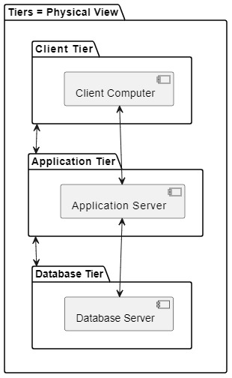

**Fig 02:**

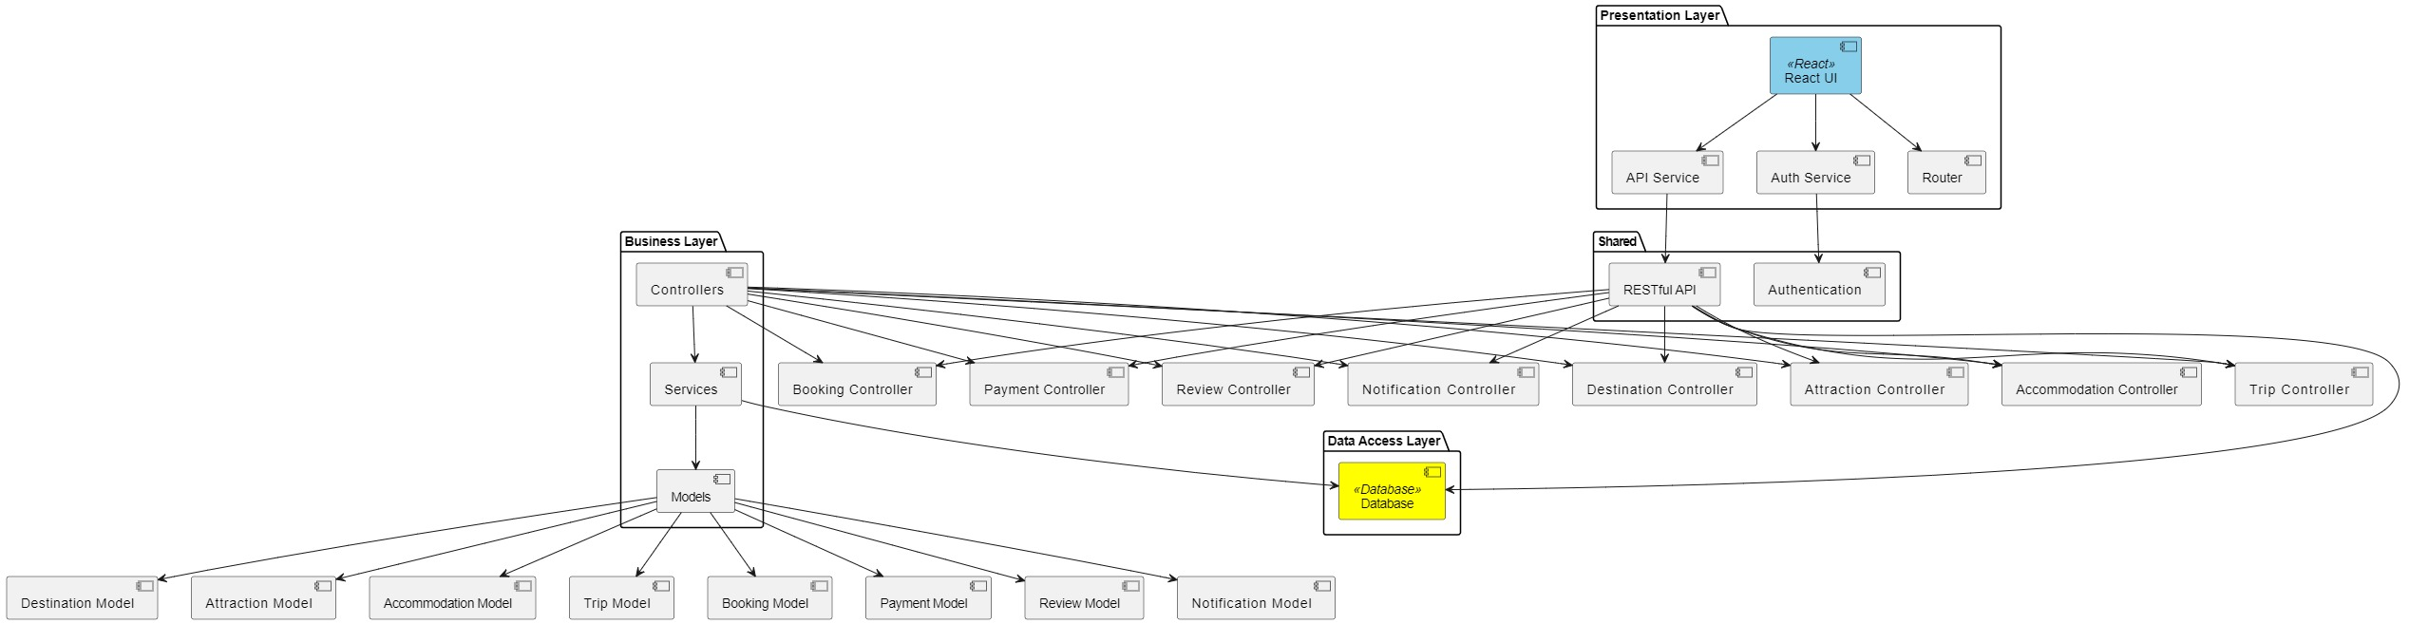

1. Class Diagram

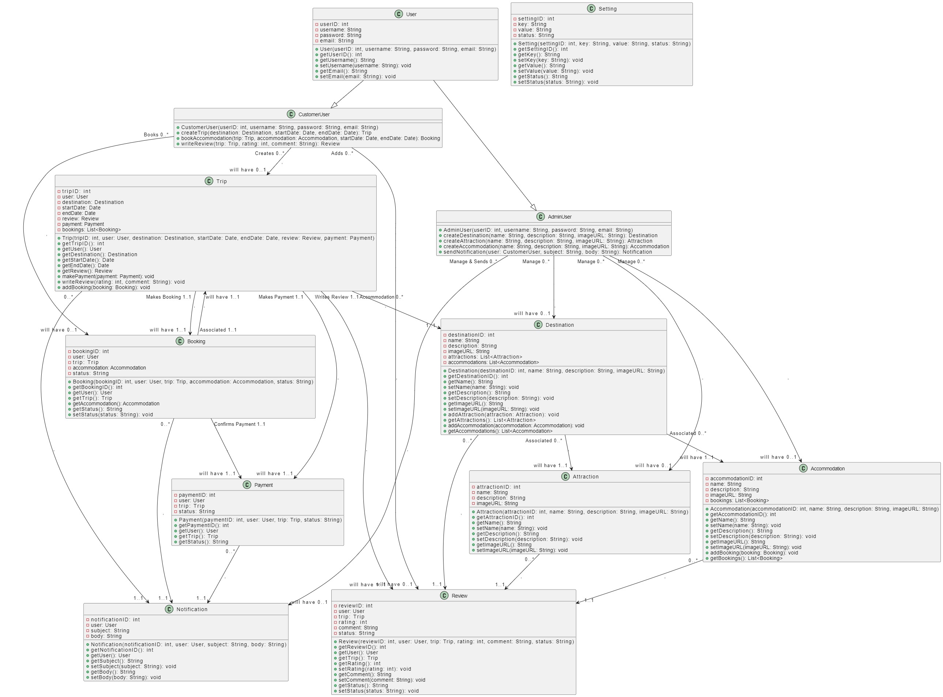

1. Database Design

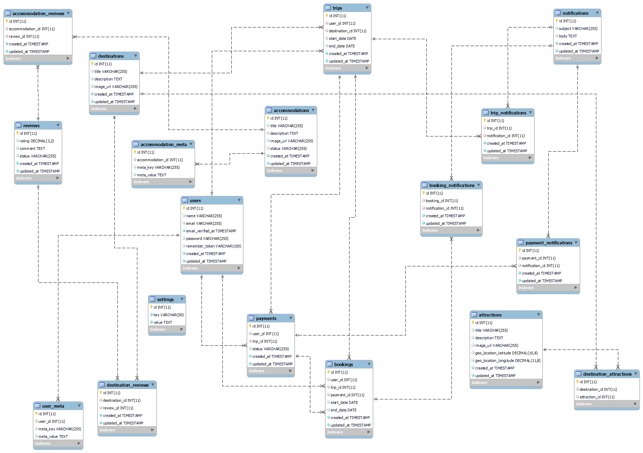

1. Interface Design

**Fig 01:**

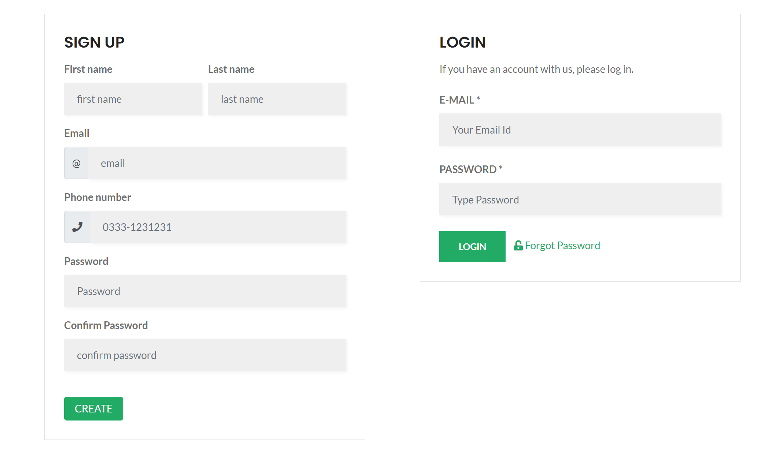

**Fig 02:**

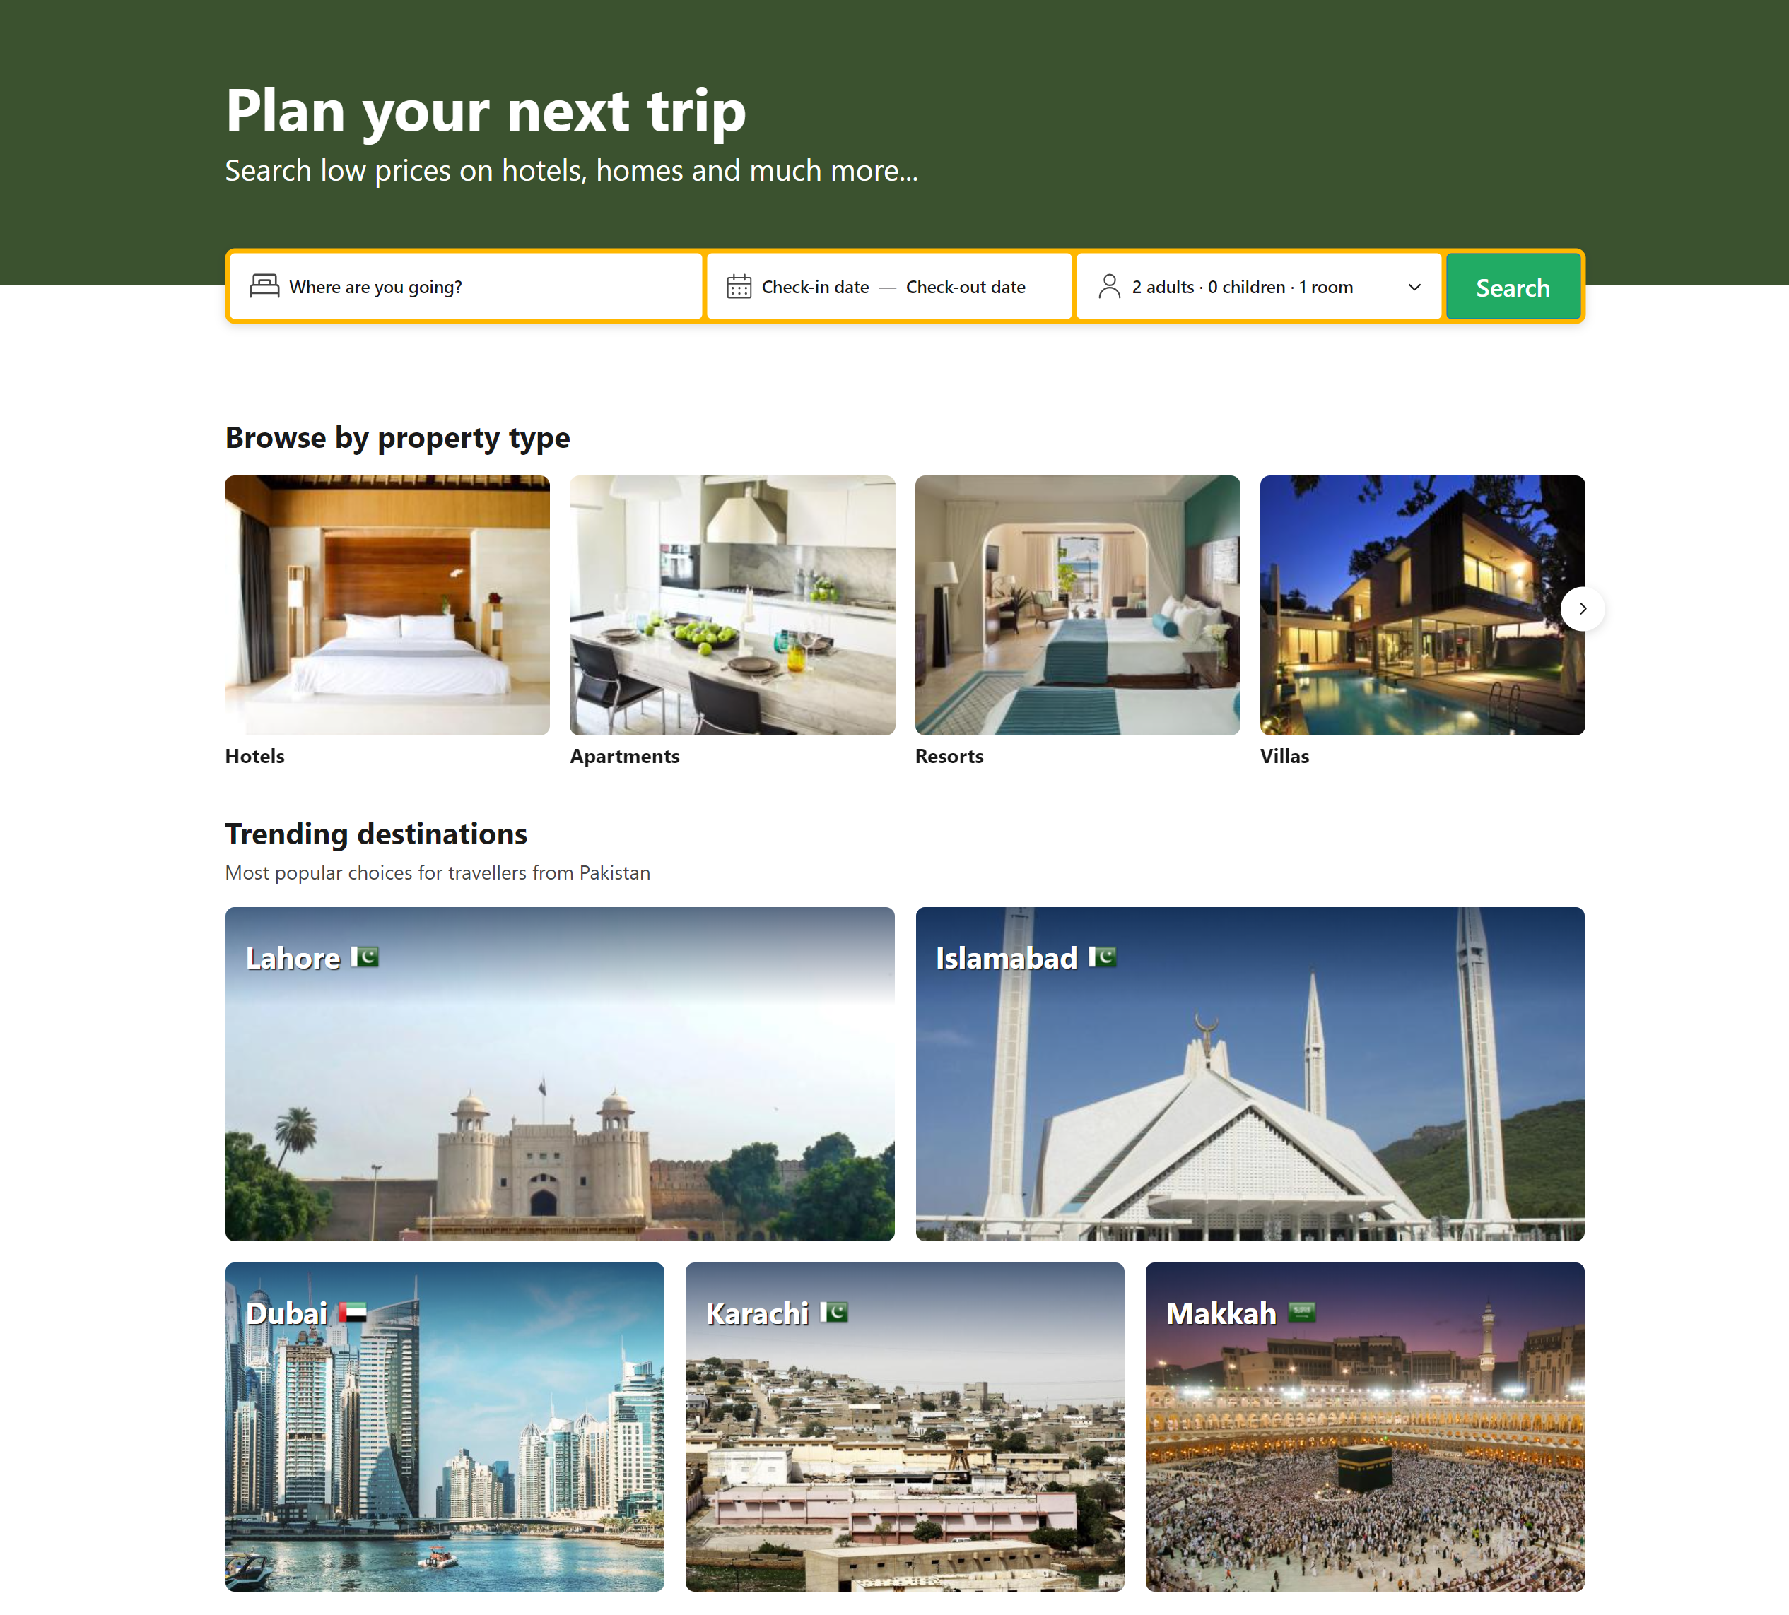

**Fig 03:**

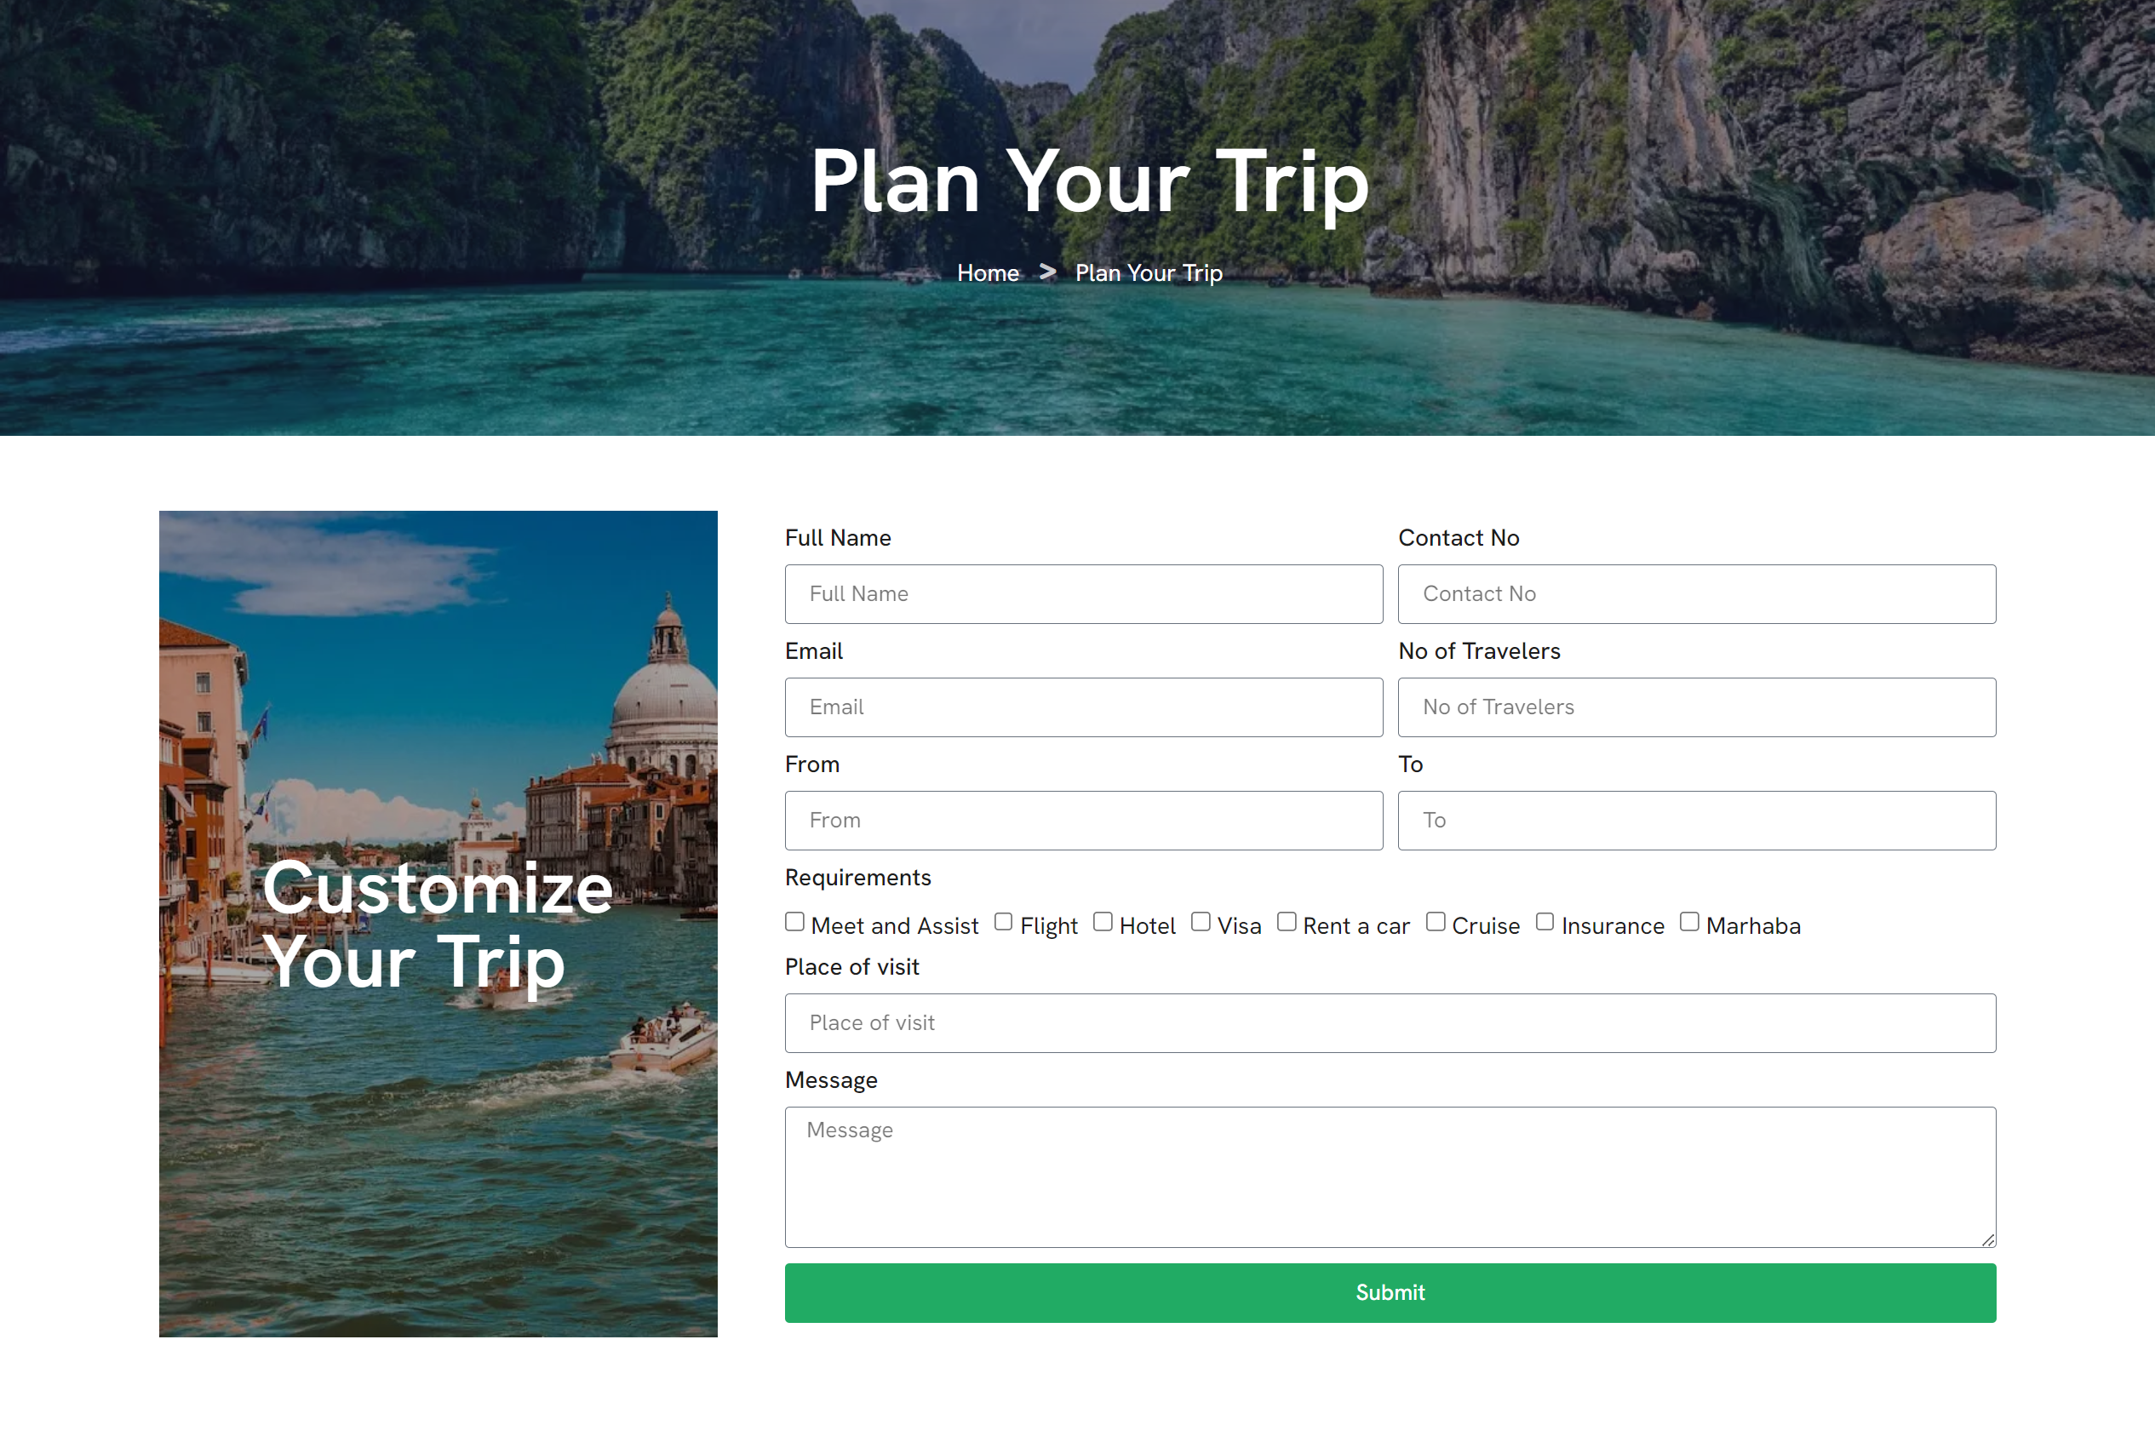

1. Test Cases

**Test Cases for Actor "Admin"**

**Test Cases for "Signup" (Use Case ID: 01)**

|  |  |
| --- | --- |
| Test Case Title | Successful Signup |
| Test Case ID | 01 |
| Precondition | The app and all relevant APIs are running. |
| Actors | Admin |
| Action | Navigate to the signup page, fill in all required fields with accurate information, and submit the form. |
| Expected Result | User receives an email confirmation for successful registration. |
| Tested By | Ejaz Ul Haq |
| Result | Pass/Fail |

|  |  |
| --- | --- |
| Test Case Title | Duplicate Email Signup |
| Test Case ID | 02 |
| Precondition | The app and all relevant APIs are running. |
| Actors | Admin |
| Action | Navigate to the signup page, fill in all required fields with an email that already exists in the database, and submit the form. |
| Expected Result | Validation error prompts user to change the email due to duplication. |
| Tested By | Ejaz Ul Haq |
| Result | Pass/Fail |

**Test Cases for "Login" (Use Case ID: 02)**

|  |  |
| --- | --- |
| Test Case Title | Successful Login |
| Test Case ID | 03 |
| Precondition | User account with valid credentials exists. |
| Actors | Admin |
| Action | Navigate to the login page, enter correct email and password, and submit the form. |
| Expected Result | User is redirected to the dashboard. |
| Tested By | Ejaz Ul Haq |
| Result | Pass/Fail |

|  |  |
| --- | --- |
| Test Case Title | Incorrect Credentials |
| Test Case ID | 04 |
| Precondition | User account with incorrect credentials. |
| Actors | Admin |
| Action | Navigate to the login page, enter incorrect email or password, and submit the form. |
| Expected Result | Validation error prompts user to correct email or password. |
| Tested By | Ejaz Ul Haq |
| Result | Pass/Fail |

**Test Cases for "Profile Management" (Use Case ID: 03)**

|  |  |
| --- | --- |
| Test Case Title | Update Profile |
| Test Case ID | 05 |
| Precondition | User is logged in and on the profile page. |
| Actors | Admin |
| Action | Update the desired field information and submit the form. |
| Expected Result | User profile is successfully updated. |
| Tested By | Ejaz Ul Haq |
| Result | Pass/Fail |

|  |  |
| --- | --- |
| Test Case Title | Missing Required Fields |
| Test Case ID | 06 |
| Precondition | User is logged in and on the profile page. |
| Actors | Admin |
| Action | Submit the form without filling in required fields. |
| Expected Result | Validation error prompts user to provide required information. |
| Tested By | Ejaz Ul Haq |
| Result | Pass/Fail |

**Test Cases for "User Management" (Use Case ID: 04)**

|  |  |
| --- | --- |
| Test Case Title | Create New User |
| Test Case ID | 07 |
| Precondition | Admin is logged in. |
| Actors | Admin |
| Action | Navigate to the users listing screen, fill in the form with new user details, and submit. |
| Expected Result | New user account is created, and the user receives an email notification. |
| Tested By | Ejaz Ul Haq |
| Result | Pass/Fail |

|  |  |
| --- | --- |
| Test Case Title | Edit User Details |
| Test Case ID | 08 |
| Precondition | Admin is on the users listing screen. |
| Actors | Admin |
| Action | Click on the edit icon for an existing user, update details, and submit the form. |
| Expected Result | User details are successfully updated, and the user receives an email notification. |
| Tested By | Ejaz Ul Haq |
| Result | Pass/Fail |

|  |  |
| --- | --- |
| Test Case Title | Delete User |
| Test Case ID | 09 |
| Precondition | Admin is on the users listing screen. |
| Actors | Admin |
| Action | Click on the delete icon for an existing user, confirm deletion. |
| Expected Result | User account is deleted, and the user receives an email notification. |
| Tested By | Ejaz Ul Haq |
| Result | Pass/Fail |

|  |  |
| --- | --- |
| Test Case Title | Validation on Form Submission |
| Test Case ID | 10 |
| Precondition | Admin is creating or updating a user. |
| Actors | Admin |
| Action | Submit the form without providing required information. |
| Expected Result | Validation error is displayed, prompting the admin to provide the necessary information. |
| Tested By | Ejaz Ul Haq |
| Result | Pass/Fail |

**Test Cases for "Content Management" (Use Case ID: 05)**

|  |  |
| --- | --- |
| Test Case Title | Add New Destination |
| Test Case ID | 11 |
| Precondition | Admin is logged in. |
| Actors | Admin |
| Action | Navigate to the destinations listing screen, fill in the form with new destination details, and submit. |
| Expected Result | New destination is added, and details are displayed in the destinations listing. |
| Tested By | Ejaz Ul Haq |
| Result | Pass/Fail |

|  |  |
| --- | --- |
| Test Case Title | Edit Destination Details |
| Test Case ID | 12 |
| Precondition | Admin is on the destinations listing screen. |
| Actors | Admin |
| Action | Click on the edit icon for an existing destination, update details, and submit the form. |
| Expected Result | Destination details are successfully updated. |
| Tested By | Ejaz Ul Haq |
| Result | Pass/Fail |

|  |  |
| --- | --- |
| Test Case Title | Delete Destination |
| Test Case ID | 13 |
| Precondition | Admin is on the destinations listing screen. |
| Actors | Admin |
| Action | Click on the delete icon for an existing destination, confirm deletion. |
| Expected Result | Destination is deleted, and associated data is removed. |
| Tested By | Ejaz Ul Haq |
| Result | Pass/Fail |

|  |  |
| --- | --- |
| Test Case Title | Validation on Form Submission |
| Test Case ID | 14 |
| Precondition | Admin is creating or updating a destination. |
| Actors | Admin |
| Action | Submit the form without providing required information. |
| Expected Result | Validation error is displayed, prompting the admin to provide the necessary information. |
| Tested By | Ejaz Ul Haq |
| Result | Pass/Fail |

**Test Cases for "Trip Management" (Use Case ID: 06)**

|  |  |
| --- | --- |
| Test Case Title | Review User-Created Trips |
| Test Case ID | 15 |
| Precondition | Admin is logged in. |
| Actors | Admin |
| Action | Navigate to the trips listing screen, review details of user-created trips. |
| Expected Result | Trip details are displayed for admin review. |
| Tested By | Ejaz Ul Haq |
| Result | Pass/Fail |

|  |  |
| --- | --- |
| Test Case Title | Verify Trip Planning |
| Test Case ID | 16 |
| Precondition | Admin is on the trips listing screen with user-created trips. |
| Actors | Admin |
| Action | Review each trip's planning details and verify for conflicts or issues. |
| Expected Result | Admin identifies and resolves any conflicts or issues in trip planning. |
| Tested By | Ejaz Ul Haq |
| Result | Pass/Fail |

|  |  |
| --- | --- |
| Test Case Title | Provide Assistance or Recommendations |
| Test Case ID | 17 |
| Precondition | Admin is on the trips listing screen with user-created trips. |
| Actors | Admin |
| Action | Provide assistance or recommendations to users planning trips. |
| Expected Result | Users receive assistance or recommendations, and details are updated. |
| Tested By | Ejaz Ul Haq |
| Result | Pass/Fail |

**Test Cases for "Accommodation Management" (Use Case ID: 07)**

|  |  |
| --- | --- |
| Test Case Title | Integrate Accommodation APIs |
| Test Case ID | 18 |
| Precondition | Admin is logged in. |
| Actors | Admin |
| Action | Navigate to the accommodation management screen, integrate 3rd party accommodation APIs. |
| Expected Result | Accommodation APIs are successfully integrated, and admin can monitor bookings. |
| Tested By | Ejaz Ul Haq |
| Result | Pass/Fail |

|  |  |
| --- | --- |
| Test Case Title | Monitor Bookings and Confirmations |
| Test Case ID | 19 |
| Precondition | Admin is on the accommodation management screen. |
| Actors | Admin |
| Action | Monitor bookings, confirmations, and cancellations in the accommodation booking system. |
| Expected Result | Admin successfully monitors and manages accommodation bookings. |
| Tested By | Ejaz Ul Haq |
| Result | Pass/Fail |

|  |  |
| --- | --- |
| Test Case Title | Handle Payment Disputes and Refunds |
| Test Case ID | 20 |
| Precondition | Admin is on the accommodation management screen. |
| Actors | Admin |
| Action | Handle payment or reservation disputes and process refunds. |
| Expected Result | Admin successfully resolves payment disputes and processes refunds. |
| Tested By | Ejaz Ul Haq |
| Result | Pass/Fail |

|  |  |
| --- | --- |
| Test Case Title | Validation on Form Submission |
| Test Case ID | 21 |
| Precondition | Admin is creating or updating accommodation information. |
| Actors | Admin |
| Action | Submit the form without providing required information. |
| Expected Result | Validation error is displayed, prompting the admin to provide the necessary information. |
| Tested By | Ejaz Ul Haq |
| Result | Pass/Fail |

**Test Cases for "Notification Management" (Use Case ID: 08)**

|  |  |
| --- | --- |
| Test Case Title | Send Custom Notifications |
| Test Case ID | 22 |
| Precondition | Admin is logged in. |
| Actors | Admin |
| Action | Navigate to the notification management screen, send custom notifications to users. |
| Expected Result | Custom notifications are sent to users, and the admin receives confirmation. |
| Tested By | Ejaz Ul Haq |
| Result | Pass/Fail |

|  |  |
| --- | --- |
| Test Case Title | Schedule Automated Notifications |
| Test Case ID | 23 |
| Precondition | Admin is on the notification management screen. |
| Actors | Admin |
| Action | Configure and schedule automated notifications for specific events. |
| Expected Result | Automated notifications are sent as per the configured schedule. |
| Tested By | Ejaz Ul Haq |
| Result | Pass/Fail |

**Test Cases for Actor "User"**

**Test Cases for "Signup" (Use Case ID: 01)**

|  |  |
| --- | --- |
| Test Case Title | Successful Signup |
| Test Case ID | 01 |
| Precondition | The app and all relevant APIs are running. |
| Actors | User |
| Action | Navigate to the signup page, fill in all required fields with accurate information, and submit the form. |
| Expected Result | User receives an email confirmation for successful registration. |
| Tested By | Ejaz Ul Haq |
| Result | Pass/Fail |

|  |  |
| --- | --- |
| Test Case Title | Duplicate Email Signup |
| Test Case ID | 02 |
| Precondition | The app and all relevant APIs are running. |
| Actors | User |
| Action | Navigate to the signup page, fill in all required fields with an email that already exists in the database, and submit the form. |
| Expected Result | Validation error prompts user to change the email due to duplication. |
| Tested By | Ejaz Ul Haq |
| Result | Pass/Fail |

**Test Cases for "Login" (Use Case ID: 02)**

|  |  |
| --- | --- |
| Test Case Title | Successful Login |
| Test Case ID | 03 |
| Precondition | User account with valid credentials exists. |
| Actors | User |
| Action | Navigate to the login page, enter correct email and password, and submit the form. |
| Expected Result | User is redirected to the dashboard. |
| Tested By | Ejaz Ul Haq |
| Result | Pass/Fail |

|  |  |
| --- | --- |
| Test Case Title | Incorrect Credentials |
| Test Case ID | 04 |
| Precondition | User account with incorrect credentials. |
| Actors | User |
| Action | Navigate to the login page, enter incorrect email or password, and submit the form. |
| Expected Result | Validation error prompts user to correct email or password. |
| Tested By | Ejaz Ul Haq |
| Result | Pass/Fail |

**Test Cases for "Profile Management" (Use Case ID: 03)**

|  |  |
| --- | --- |
| Test Case Title | Update Profile |
| Test Case ID | 05 |
| Precondition | User is logged in and on the profile page. |
| Actors | User |
| Action | Update the desired field information and submit the form. |
| Expected Result | User profile is successfully updated. |
| Tested By | Ejaz Ul Haq |
| Result | Pass/Fail |

|  |  |
| --- | --- |
| Test Case Title | Missing Required Fields |
| Test Case ID | 06 |
| Precondition | User is logged in and on the profile page. |
| Actors | User |
| Action | Submit the form without filling in required fields. |
| Expected Result | Validation error prompts user to provide required information. |
| Tested By | Ejaz Ul Haq |
| Result | Pass/Fail |

**Test Cases for "Trip Planning" (Use Case ID: 09)**

|  |  |
| --- | --- |
| Test Case Title | Create New Trip |
| Test Case ID | 07 |
| Precondition | User is logged in and on the trip planning screen. |
| Actors | User |
| Action | Fill in the required fields for a new trip and submit the form. |
| Expected Result | New trip is successfully created. |
| Tested By | Ejaz Ul Haq |
| Result | Pass/Fail |

|  |  |
| --- | --- |
| Test Case Title | Edit Trip Details |
| Test Case ID | 08 |
| Precondition | User has created a trip and is on the trip details screen. |
| Actors | User |
| Action | Edit trip details, such as destination, dates, and purpose, and submit the form. |
| Expected Result | Trip details are successfully updated. |
| Tested By | Ejaz Ul Haq |
| Result | Pass/Fail |

|  |  |
| --- | --- |
| Test Case Title | Validation on Form Submission |
| Test Case ID | 09 |
| Precondition | User is creating or updating a trip. |
| Actors | User |
| Action | Submit the form without providing required information. |
| Expected Result | Validation error is displayed, prompting the user to provide the necessary information. |
| Tested By | Ejaz Ul Haq |
| Result | Pass/Fail |

|  |  |
| --- | --- |
| Test Case Title | Delete Trip |
| Test Case ID | 10 |
| Precondition | User is logged in and on the trip planning screen. |
| Actors | User |
| Action | Click on the delete icon for a trip, confirm deletion. |
| Expected Result | Trip is deleted, and associated data is removed. |
| Tested By | Ejaz Ul Haq |
| Result | Pass/Fail |

**Test Cases for "Destination Information" (Use Case ID: 10)**

|  |  |
| --- | --- |
| Test Case Title | Search for Destination |
| Test Case ID | 11 |
| Precondition | User is logged in and on the destination search screen. |
| Actors | User |
| Action | Type keywords in the search bar and wait for the result processing. |
| Expected Result | Search results are displayed with relevant destination information. |
| Tested By | Ejaz Ul Haq |
| Result | Pass/Fail |

|  |  |
| --- | --- |
| Test Case Title | View Detailed Destination Information |
| Test Case ID | 12 |
| Precondition | User is on the destination search screen with search results. |
| Actors | User |
| Action | Click on the view detail button for a destination. |
| Expected Result | Detailed destination information is displayed, including climate, local culture, attractions, etc. |
| Tested By | Ejaz Ul Haq |
| Result | Pass/Fail |

|  |  |
| --- | --- |
| Test Case Title | Associate Destination with Trip |
| Test Case ID | 13 |
| Precondition | User has created a trip and is on the destination details screen. |
| Actors | User |
| Action | Associate the destination with the created trip. |
| Expected Result | Destination is successfully associated with the trip. |
| Tested By | Ejaz Ul Haq |
| Result | Pass/Fail |

|  |  |
| --- | --- |
| Test Case Title | Validation on Form Submission |
| Test Case ID | 14 |
| Precondition | User is creating or updating a destination. |
| Actors | User |
| Action | Submit the form without providing required information. |
| Expected Result | Validation error is displayed, prompting the user to provide the necessary information. |
| Tested By | Ejaz Ul Haq |
| Result | Pass/Fail |

|  |  |
| --- | --- |
| Test Case Title | Un-Associate Destination |
| Test Case ID | 15 |
| Precondition | User is logged in and on the destination information screen. |
| Actors | User |
| Action | Click on the delete icon for a destination, confirm deletion. |
| Expected Result | Destination is deleted, and associated data is removed. |
| Tested By | Ejaz Ul Haq |
| Result | Pass/Fail |

**Test Cases for "Accommodation Booking" (Use Case ID: 11)**

|  |  |
| --- | --- |
| Test Case Title | Search for Accommodation |
| Test Case ID | 16 |
| Precondition | User is logged in and on the accommodation search screen. |
| Actors | User |
| Action | Type keywords in the search bar and wait for the result processing. |
| Expected Result | Search results are displayed with relevant accommodation information. |
| Tested By | Ejaz Ul Haq |
| Result | Pass/Fail |

|  |  |
| --- | --- |
| Test Case Title | View Detailed Accommodation Information |
| Test Case ID | 17 |
| Precondition | User is on the accommodation search screen with search results. |
| Actors | User |
| Action | Click on the view detail button for an accommodation. |
| Expected Result | Detailed accommodation information is displayed, including options, availability, etc. |
| Tested By | Ejaz Ul Haq |
| Result | Pass/Fail |

|  |  |
| --- | --- |
| Test Case Title | Associate Accommodation with Trip |
| Test Case ID | 18 |
| Precondition | User has created a trip and is on the accommodation details screen. |
| Actors | User |
| Action | Associate the accommodation with the created trip. |
| Expected Result | Accommodation is successfully associated with the trip. |
| Tested By | Ejaz Ul Haq |
| Result | Pass/Fail |

|  |  |
| --- | --- |
| Test Case Title | Validation on Form Submission |
| Test Case ID | 19 |
| Precondition | User is creating or updating an accommodation. |
| Actors | User |
| Action | Submit the form without providing required information. |
| Expected Result | Validation error is displayed, prompting the user to provide  the necessary information. |
| Tested By | Ejaz Ul Haq |
| Result | Pass/Fail |

|  |  |
| --- | --- |
| Test Case Title | Un-Associate/Remove Accommodation |
| Test Case ID | 20 |
| Precondition | User is logged in and on the accommodation booking screen. |
| Actors | User |
| Action | Click on the delete icon for an accommodation, confirm deletion. |
| Expected Result | Accommodation is deleted, and associated data is removed. |
| Tested By | Ejaz Ul Haq |
| Result | Pass/Fail |

**Test Cases for "Reviews and Ratings" (Use Case ID: 12)**

|  |  |
| --- | --- |
| Test Case Title | View Reviews and Ratings |
| Test Case ID | 21 |
| Precondition | User is logged in and on the destination or accommodation details screen. |
| Actors | User |
| Action | View reviews and ratings added by other users. |
| Expected Result | Reviews and ratings are displayed for the destination or accommodation. |
| Tested By | Ejaz Ul Haq |
| Result | Pass/Fail |

|  |  |
| --- | --- |
| Test Case Title | Add Review and Rating |
| Test Case ID | 22 |
| Precondition | User is logged in and on the destination or accommodation details screen. |
| Actors | User |
| Action | Write a comment, give ratings, and submit the review form. |
| Expected Result | User's review and rating are successfully added. |
| Tested By | Ejaz Ul Haq |
| Result | Pass/Fail |

|  |  |
| --- | --- |
| Test Case Title | Validation on Form Submission |
| Test Case ID | 23 |
| Precondition | User is adding a review and rating. |
| Actors | User |
| Action | Submit the form without providing required information. |
| Expected Result | Validation error is displayed, prompting the user to provide the necessary information. |
| Tested By | Ejaz Ul Haq |
| Result | Pass/Fail |